**VIETNAM NATIONAL UNIVERSITY – HO CHI MINH CITY**

**INTERNATIONAL UNIVERSITY**

**School of Computer Science and Engineering**



**ARTIFICIAL INTELLIGENCE**

**IT159IU**

PROJECT REPORT

Course by Dr. Le Thanh Sach and Dr. Ly Tu Nga

**Topic:**

**WATER QUALITY PREDICTION**

GROUP 15 - **TEAM MEMBERS**

1. Phan Quốc Anh ITDSIU21001
2. Nguyễn Quốc Huy ITDSIU21067

**HCMC - May 2024**

**Group Member Contribution Table**

|  |  |  |  |
| --- | --- | --- | --- |
| **Student Name** | **Student ID** | **Task** | **Percentage of contribution** |
| Phan Quốc Anh | ITDSIU21001 | Data Preprocessing and Comparison | **50%** |
| Nguyễn Quốc Huy | ITDSIU21067 | EDA and modeling | **50%** |

**TABLE OF CONTENTS**

ABSTRACT 5

CHAPTER I: INTRODUCTION 6

**1.** About the project 6

1.1 Goal 6

1.2 Description 6

**2.** Dataset 6

**3.** The techniques and tools used 7

CHAPTER II: DATA PREPROCESSING AND EDA 8

**1.** **Data Preprocessing** 8

1.1 Description of Attributes 8

1.2 Check for duplicate rows 9

1.3 Check for missing values 10

1.4 Outliers Detection and handling 12

**2. EDA** 14

2.1 Initial inspection 14

2.2 Correlation matrix 15

2.3 Statistical plots 16

CHAPTER III: MODELING AND EVALUATION 19

**0. Prepare data for modeling** 19

**1.** **Logistic Regression** 20

**2.** **Random Forest Classifier** 21

**3.** **SVM (Support Vector Machine)** 23

**4.** **Gradient Boosting** 24

**5.** **Neural Network** 26

CHAPTER IV: COMPARISION 29

CHAPTER V: CONCLUSION AND FUTURE WORK 33

**1.** **Conclusion** 33

**2.** **Future work** 33

REFERENCES 35

Figure 2. 1 Dataset's Description 8

Figure 2. 2: Checking for Duplicates 9

Figure 2. 3: Checking for missing value 10

Figure 2. 4: Distribution of the three missing value 10

Figure 2. 5: Sample of Sulfate 10

Figure 2. 6: Handle missing values 11

Figure 2. 7: BoxPlots 12

Figure 2. 8: Outlier in Sulfate 12

Figure 2. 9: Overview of Data 13

Figure 2. 10: Summary statistics of the dataset 13

Figure 2. 11: Distribution of Potability 14

Figure 2. 12: Correlation Matrix 14

Figure 2. 13: Distribution of Attributes 15

Figure 2. 14: Pair Plots 16

Figure 2. 15: Violin Plots 17

Figure 3. 1: Divide the Dataset 18

Figure 3. 2: Scaling the Data 18

Figure 3. 3: Split the Data 19

Figure 3. 4: Logistic Regression's Classification Report 20

Figure 3. 5: Logistic Regression's Confusion Matrix 20

Figure 3. 6: Random Forest's Classification Report 21

Figure 3. 7: Random Forest's Confusion Matrix 21

Figure 3. 8: SVM's Classification Report 23

Figure 3. 9: SVM's Confusion Matrix 23

Figure 3. 10: Gradient Boosting's Classification Report 24

Figure 3. 11: Gradient Boosting's Confusion Matrix 25

Figure 3. 12: Neural Network's Classification Report 26

Figure 3. 13: Neural Network's Confusion Matrix 27

Figure 4. 1: Compare Function 28

Figure 4. 2: Comparison Results 29

Figure 4. 3: Chart of Performance Metrics 29

Figure 4. 4: Timing Table 30

Figure 5. 1: SVM in 3D 33

# ABSTRACT

In the face of escalating water pollution, the imperative to assess water quality has never been more critical. This project addresses the challenge of predicting water potability using a dataset sourced from Kaggle, which includes various chemical properties of water. Our objective was to employ and evaluate multiple machine learning models to determine the potability of water based on its chemical characteristics. The models tested include Logistic Regression, Random Forest, Support Vector Machines (SVM), Gradient Boosting, and Neural Networks. Each model was assessed based on its accuracy, precision, recall, and F1 score, as well as its training and prediction times. The SVM model demonstrated superior performance with the highest accuracy and precision, making it the preferred model despite its relatively longer prediction time. This report details the data preprocessing steps, exploratory data analysis, model evaluation, and comparisons that underpin our findings. Our results indicate that machine learning can effectively contribute to environmental science, particularly in water quality management. Future work may explore more complex ensemble techniques and deep learning models to further enhance prediction accuracy.

# CHAPTER I: INTRODUCTION

## **1.** About the project

### 1.1 Goal

The primary goal of this project is to analyse the chemical properties of water to determine its potability. By leveraging a comprehensive dataset from Kaggle, we apply various machine learning algorithms, including Support Vector Machines (SVM) and Logistic Regression, to predict which components contribute to making water potable and to derive the most accurate models for this purpose.

### 1.2 Description

This section outlines the models and methods utilized in this project. The data undergoes initial preprocessing to filter and partition it into training and testing sets. We then apply different machine learning strategies to achieve the most accurate predictions:

+ Logistic Regression: Serves as a fundamental model for binary classification, offering simplicity and interpretability, ideal for benchmarking more complex approaches.

+ Random Forest: This ensemble method uses multiple decision trees to enhance generalization and reduce overfitting, providing insights into feature importance for potability prediction.

+ Support Vector Machines (SVM): Known for its effectiveness in high-dimensional spaces, SVM is adaptable with various kernels, making it suitable for datasets with ambiguous class boundaries.

+ Gradient Boosting Machines (GBM): A robust ensemble technique that iteratively corrects errors from previous models, often achieving high performance across diverse data types, including imbalanced datasets.

+ Neural Networks: Suitable for complex pattern recognition, these models require substantial data and careful tuning of architecture parameters, including layer depth and neuron counts per layer.

## **2.** Dataset

Water covers 97% of Earth's surface, yet only a small fraction is usable daily. Increasing industrial activities have exacerbated water pollution, especially in urban and industrial regions in Vietnam, where up to 70% of water from industrial zones is discharged untreated. The dataset used in this project comprises various water quality metrics from multiple sources, offering a basis to assess potability based on chemical composition.

The link of the data: <https://www.kaggle.com/code/nimapourmoradi/water-potability>

## **3.** The techniques and tools used

Google Colab: Provides a cloud-based Jupyter Notebook environment with access to computational resources such as GPUs and TPUs.

Libraries:

* NumPy: Handles array operations and mathematical computations.
* Pandas: Facilitates data manipulation and analysis.
* Matplotlib and Seaborn: Used for visualizing data.
* scikit-learn: Offers tools for machine learning tasks.
* plotly.graph_objects is a module within the Plotly library for Python that provides a flexible and powerful interface for creating a wide range of interactive and highly customizable visualizations.

This revised introduction provides a clearer, more professional overview of your project's objectives, methods, data, and tools, setting a well-defined stage for the detailed content that follows in the report.

# CHAPTER II: DATA PREPROCESSING AND EDA

This chapter covers data preprocessing and EDA (Exploratory Data Analysis) to consider values that can be used to predict whether water is potable or not. Relatively large data sets can give misleading results if the data is not cleaned and understood.

Before going to the two parts above, we import libraries, modules and load the dataset using Python running on Google Colab:

[1]

import pandas as pd

import numpy as np

import seaborn as sns

import matplotlib.pyplot as plt

import plotly.express as px

import plotly.graph_objects as go

from sklearn.model_selection import train_test_split

from sklearn.impute import SimpleImputer

from sklearn.preprocessing import StandardScaler

from sklearn.model_selection import GridSearchCV, RandomizedSearchCV

from sklearn.metrics import accuracy_score, precision_score, recall_score, f1_score, roc_auc_score, confusion_matrix

from sklearn.linear_model import LogisticRegression

from sklearn.ensemble import RandomForestClassifier, GradientBoostingClassifier

from sklearn.svm import SVC

from sklearn.neural_network import MLPClassifier

import warnings

warnings.filterwarnings('ignore')

[2]

# load dataset

df = pd.read_csv('https://raw.githubusercontent.com/quocanhphan/Water-Quality-Prediction/main/data/water_potability.csv')

## **Data Preprocessing**

### 1.1 Description of Attributes

First, in the pre-processing step, we need to observe the data, understand clearly the type of data and how the values ​​are related.

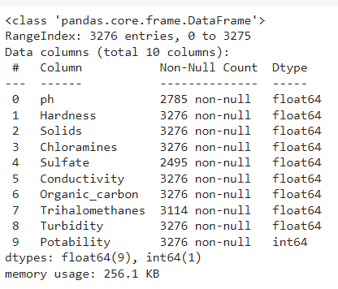

Figure 2. 1 Dataset's Description

Using df.info() to observe the data, we can see that:

+ the data frame has 3276 entries and 10 columns

+ the data type of the first 9 columns is float64, while the data type of the target column is int64

Here is the **specific description** of the attributes:

* The dataset includes the following key attributes:
* ph: pH of the water (float).
* Hardness: Hardness of the water (float).
* Solids: Total dissolved solids in water (float).
* Chloramines: Amount of Chloramines in water (float).
* Sulfate: Amount of Sulfates in water (float).
* Conductivity: Electrical conductivity of the water (float).
* Organic_carbon: Amount of organic carbon in water (float).
* Trihalomethanes: Concentration of Trihalomethanes (float).
* Turbidity: Measure of water turbidity (float).
* Potability: Indicates if water is potable (1 for potable, 0 for not potable) (integer). [**target**]

### Check for duplicate rows

The next step is to examine the dataset for duplicate entries. Duplicates can arise during data collection or integration and may lead to skewed analysis and biased model training if not appropriately handled. This step is vital for preventing the overrepresentation of any information, which is particularly important for maintaining the generalizability of the predictive models.

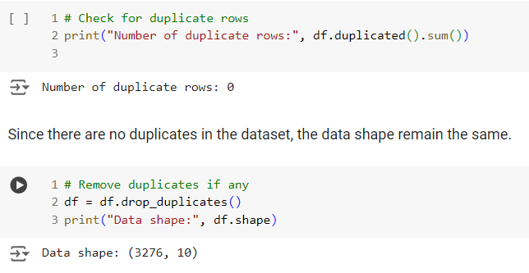

Figure 2. 2: Checking for Duplicates

Fortunately, there is no duplicated rows in the dataset, we don’t have to handle.

### Check for missing values

The next step in data preprocessing involves identifying any missing entries within the dataset. This is crucial as missing values can significantly impact the performance of machine learning models by introducing bias or causing errors during training.

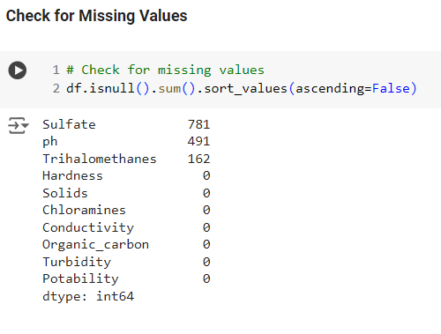

Figure 2. 3: Checking for missing value

As we can see here, there exist missing values in the three attributes: Sulfate, pH and Trihalomethanes with 781, 491 and 162 missing values respectively. So how can we handle them?

First, we win print out the distribution of the three attributes using histogram and line KDE to look at them.

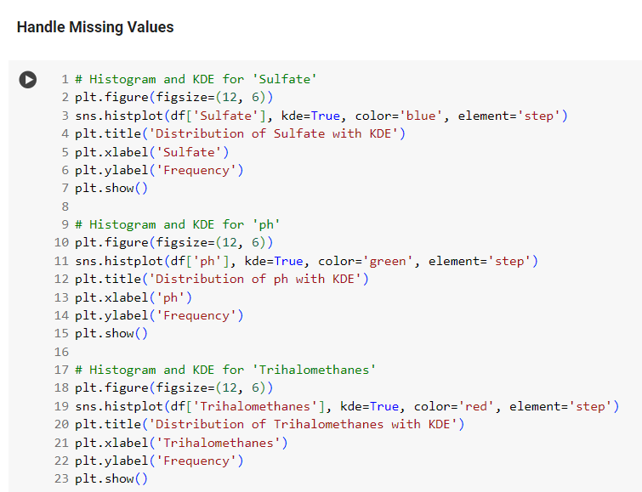

Figure 2. 4: Distribution of the three missing value

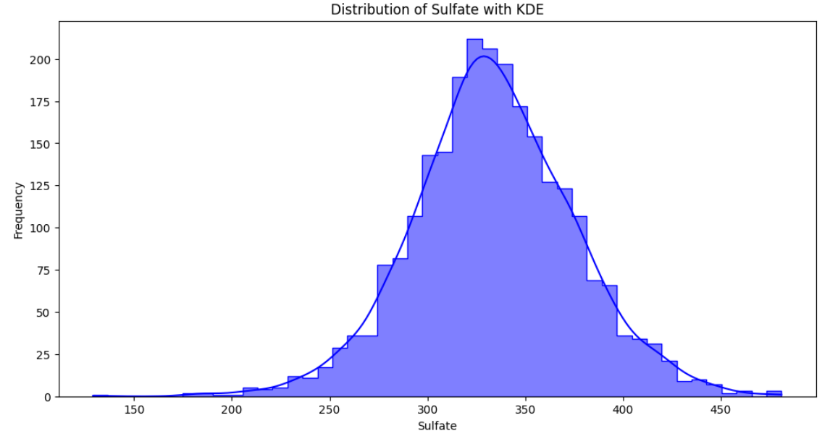

Figure 2. 5: Sample of Sulfate

From the distributions, we think that the data is not normally distributed so we will use the median to fill missing values. The filling technique is using the SimpleImputer with strategy is ‘median’:

|  |
| --- |
|   Figure 2. 6: Handle missing values |

After that we check again to make sure that there are no more missing values in the data.

### 1.4 Outliers Detection and handling

Next is outlier detection and handling. Apply subplots to calculate and draw boxplots to give a clearer and more intuitive view.

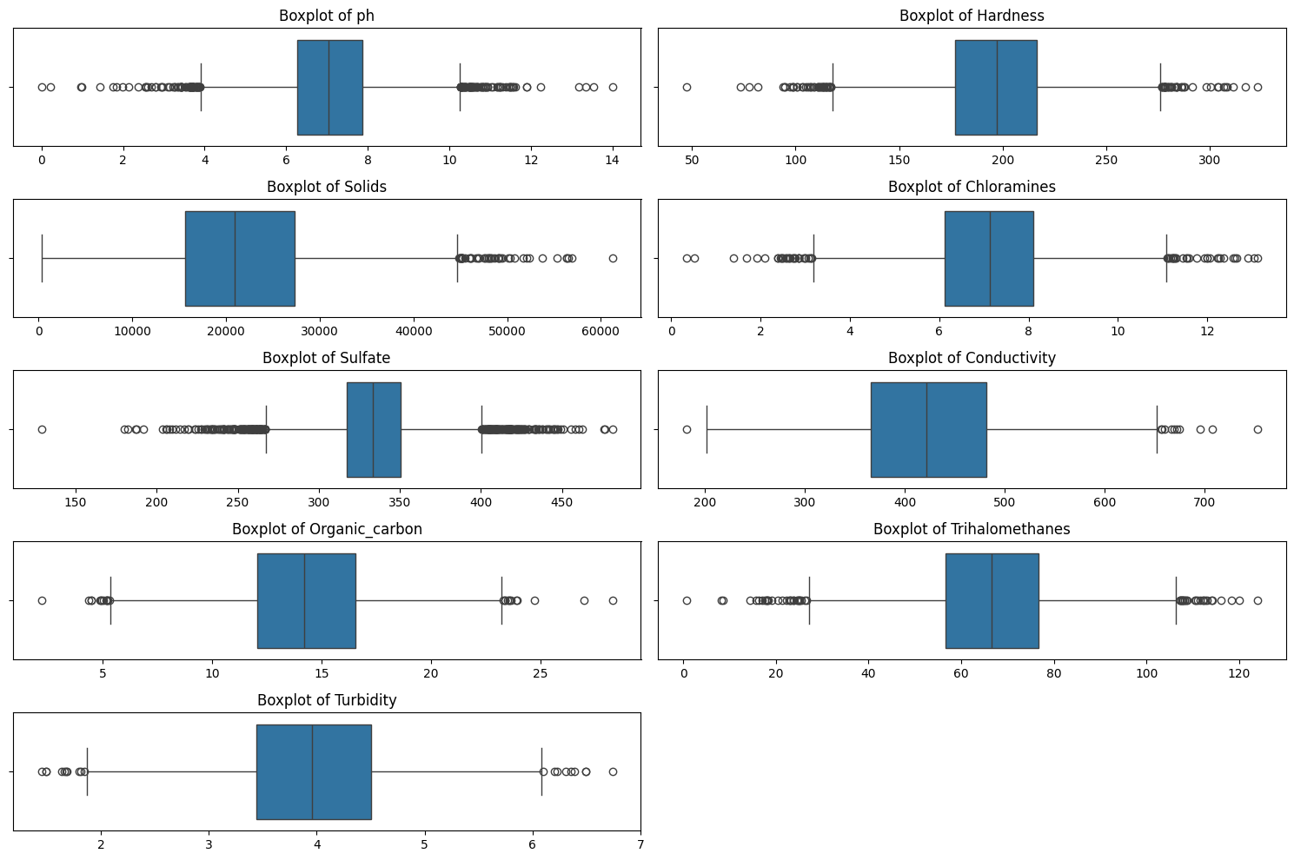

Figure 2. 7: BoxPlots

The boxplot of attribute ‘Sulfate’ seems to the one that has most outliers so we will examine more closely.

Below is an example of detecting outliers in the “sulfate”:

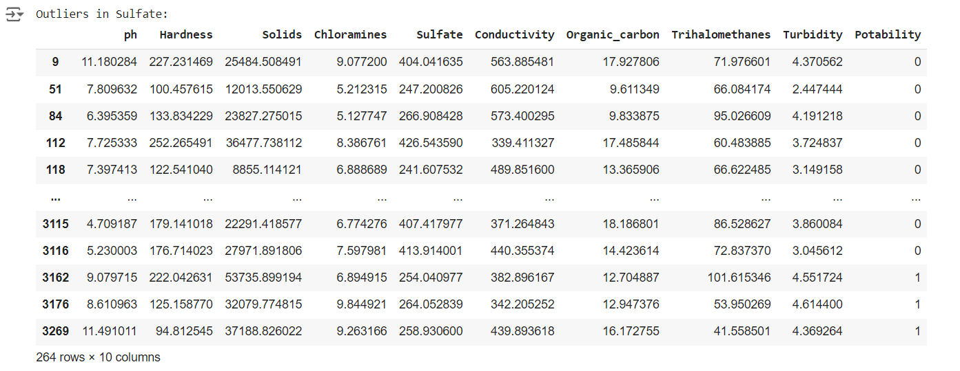

Figure 2. 8: Outlier in Sulfate

After viewing the table above, we decide not to handle outliers due to below reasons:

* the nature of water quality data, where outliers could represent significant. These extreme values are crucial for accurately predicting water potability.
* the Machine Learning models like Random Forest and Gradient Boosting are robust to outliers, they can effectively manage these extremes without prior modifications.

Thus, retaining outliers allows the models to recognize and respond to critical water quality changes, enhancing the practical utility of our predictions in real-world scenarios.

## **2. EDA**

### 2.1 Initial inspection

Exploratory data analysis is the step used to evaluate the overall data. to show the structures, relationships and types of value that data brings so that it can be refined and expressed more accurately.

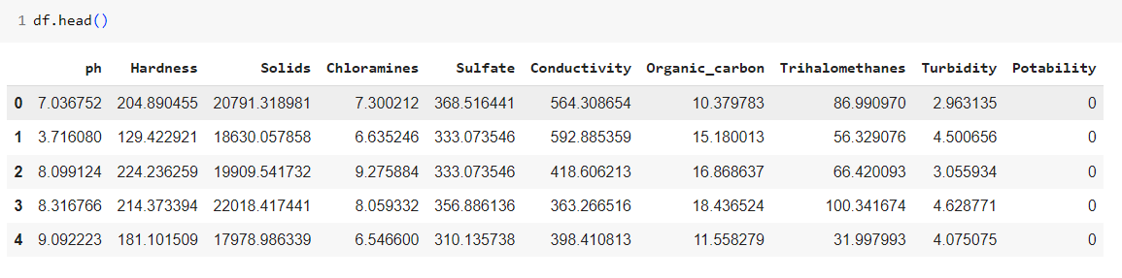

Figure 2. 9: Overview of Data

In this description step, using the describe function can quickly give all the information that the data set has. Shows the average value, standard deviation as well as other indicators to help workers have a more accurate view

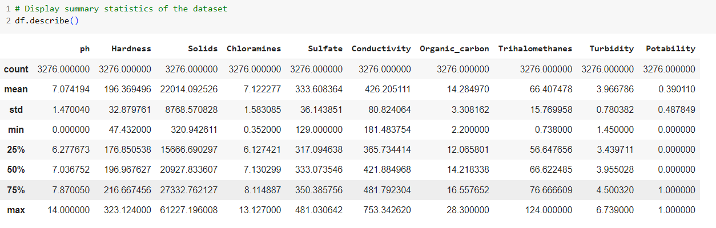

Figure 2. 10: Summary statistics of the dataset

We have determined the priority value and extracted the comment as "potability" so before cleaning or analysis, the bar graph below will be distributed for easy viewing.

**Distribution of the target variable 'Potability' (1 for potable, 0 for not potable)**

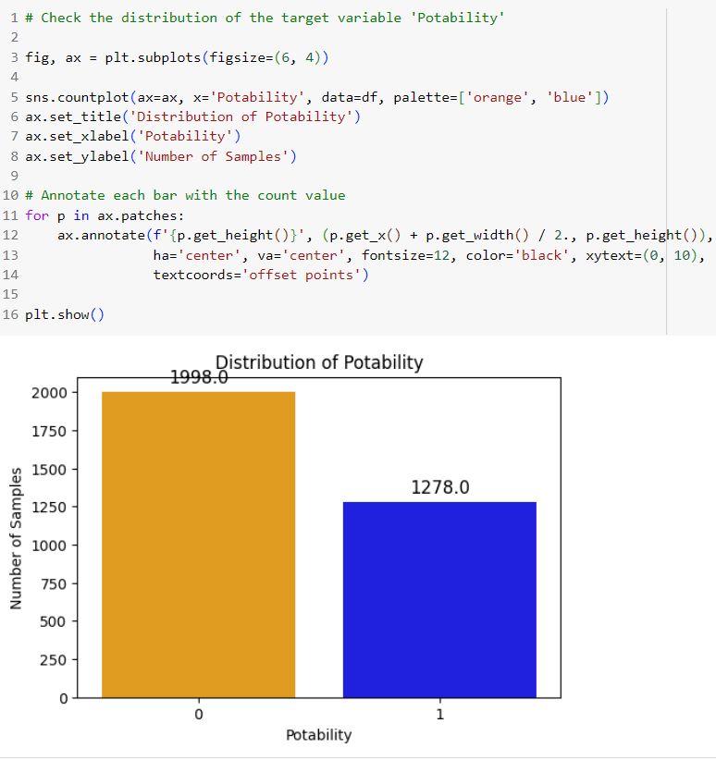

Figure 2. 11: Distribution of Potability

### 2.2 Correlation matrix

To check the correlation level of the "Potability" value, the correlation matrix is ​​used to have a better view of the relationship between values ​​with each other and between "Potability” and other values.

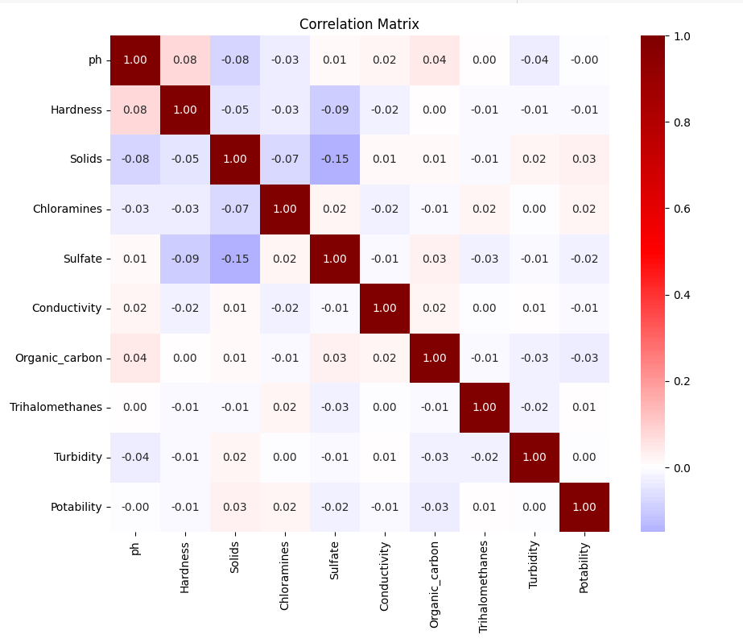

Figure 2. 12: Correlation Matrix

Here, we can easily see that there are two attributes that have a typical correlation with the “Potability” attribute:

- "Solids" as the positive correlation with 0.03

- " Organic _Carbon" as the negative correlation with -0.03.

### 2.3 Statistical plots

The distribution plots of the nine attributes:

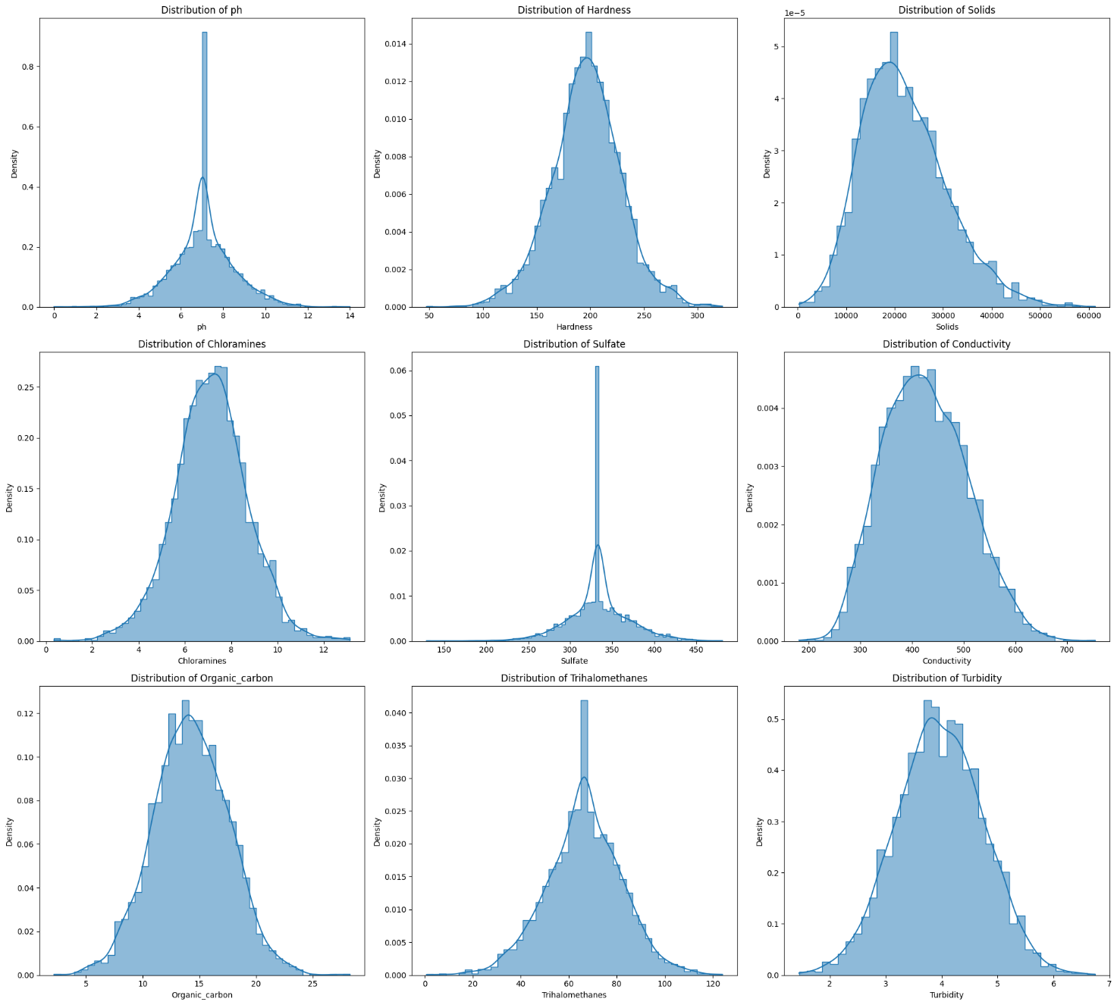

Figure 2. 13: Distribution of Attributes

These distributions provide crucial insights into the overall water quality within the sampled area. The generally normal distributions of many parameters suggest controlled and consistent conditions in water treatment facilities. However, the right-skewed distributions seen in sulfate and trihalomethanes highlight areas where water quality could vary significantly, potentially affecting its safety and suitability for consumption.

To understand trends in data, seaborn's pair chart is used to visualize pairwise relationships between features.

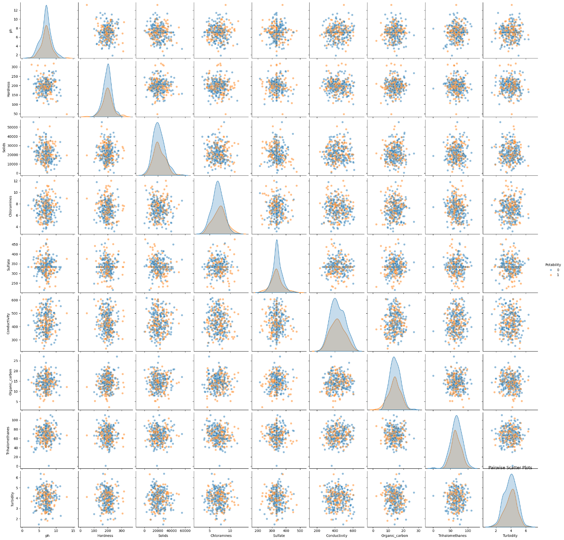

Figure 2. 14: Pair Plots

Violin plot is a type of graph used to display the distribution of data. It combines the features of a box plot and a kernel density plot.

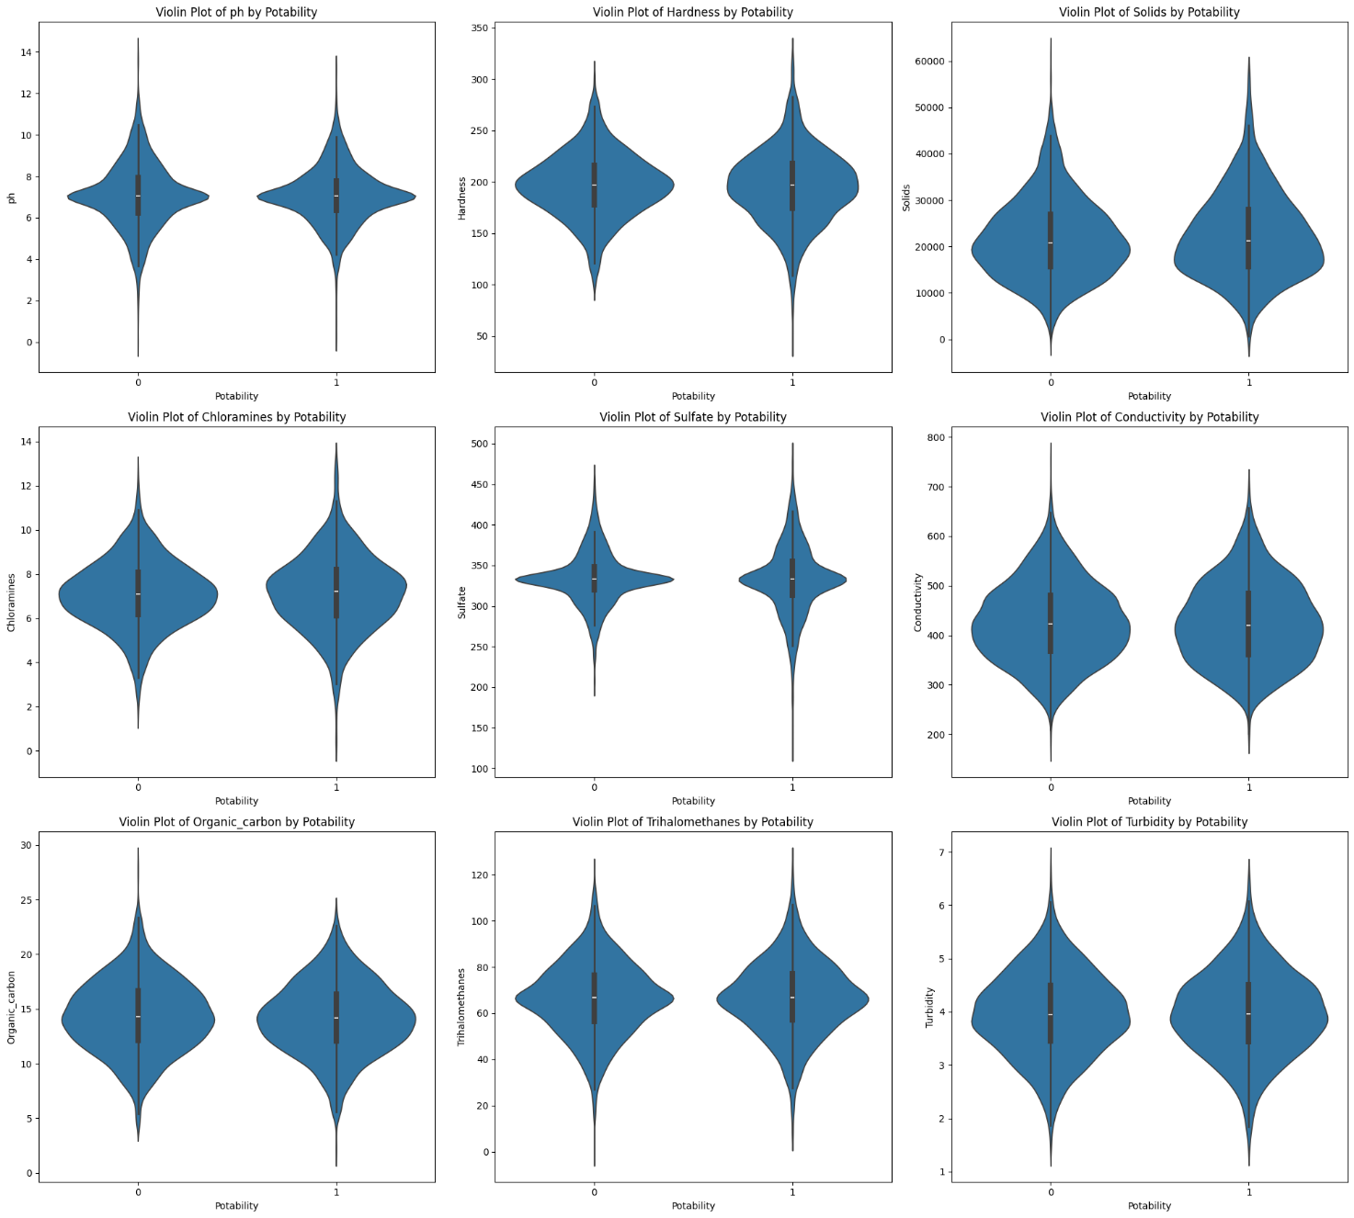

Figure 2. 15: Violin Plots

In our project, violin plots are employed to visually assess the distribution of water quality metrics across different potability statuses. Each plot represents a feature, such as pH or sulfate levels, with the thickness of the violin indicating the frequency of data points at different values. The wider sections of the violin show where data is more concentrated, while the slimmer parts indicate less frequent observations.

# CHAPTER III: MODELING AND EVALUATION

## **0. Prepare data for modeling**

* To prepare for running on models, dividing the data into independent and dependent variables.

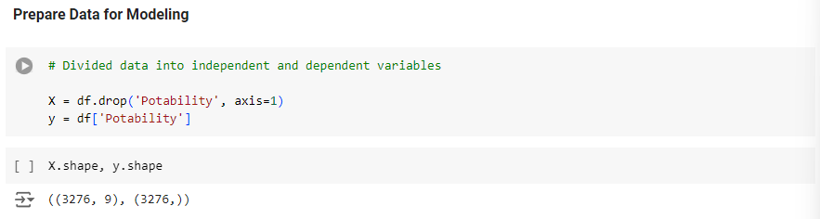

Figure 3. 1: Divide the Dataset

* Before deploying machine learning models, it's crucial to ensure that all features are on a similar scale. This is especially important when using algorithms that compute distances between data points, such as SVM or KNN, and for optimizing performance in gradient descent-based algorithms. In this project, we use the StandardScaler from scikit-learn to standardize the features to have a mean of zero and a standard deviation of one. Standardization involves subtracting the mean and then scaling to unit variance:

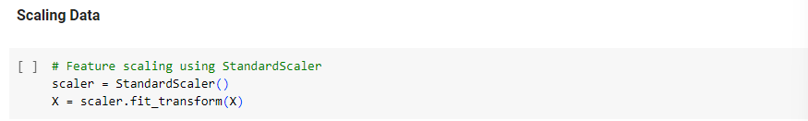

Figure 3. 2: Scaling the Data

This transformation normalizes the distribution of the features, reducing the bias that can occur with features that operate on different scales.

* In this project, the data will be divided into 2 parts with a ratio of 80-20, 80% for training and 20% for testing. This ensures that our model can be trained and validated effectively before being tested on unseen data.

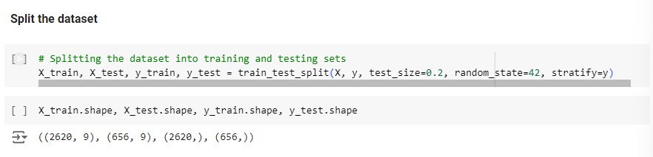

Figure 3. 3: Split the Data

After these above steps, now we deploy the 5 models to deal with this classification project, which are: Logistic Regression, Random Forest, Support Vector Machine, Gradient Boosting and Neural Networks.

1. **Logistic Regression**

Logistic Regression is a statistical method used for modeling binary or multiclass data. It is a type of regression model, but instead of predicting a continuous value like linear regression, it predicts the probability of one of two or more classes.

P(y=1∣X)=σ(z)=1+e−z1 ${\left(1+x\right)}^{n}=\frac{1}{1+e^{-z}}$

​

Where:

* z=wTX +b : is a linear combination of the features.
* w is the weight vector, X is the feature vector, and b is the bias term.

Model training process

1. **Objective Function:** The objective function to optimize in logistic regression is the loss function, specifically the cross-entropy loss:

$$L(w,b)=-\frac{1}{m}\sum_{i=1}^{m}{\left(y_{i}\log{y_{i}}+(1-y_{i}​)\log{(1-y_{i}}\right))}$$

Where:

* m is the number of samples in the training set.
* $y_{i}$ is the actual label of the iii-th sample.
* y^​i​ is the predicted probability of the i-th sample.

Weight Update: Using optimization algorithms such as gradient descent to update the w and bias b to minimize the loss function.

Then after using the model to train and test, the results

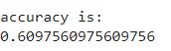

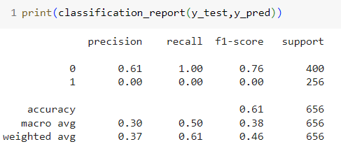

Figure 3. 4: Logistic Regression's Classification Report

Based on the classification report table, we can see different data and accuracy through each result value such as f1-score, precision or recall.

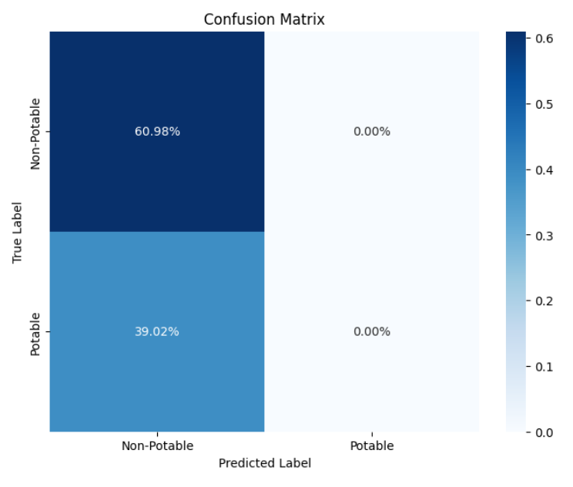

Figure 3. 5: Logistic Regression's Confusion Matrix

Based on the confusion matrix table, we can see that the prediction results are clearly divided into different parts for observation. There is 60.98% of data that is true positive and 39.02% false negative.

1. **Random Forest Classifier**

**Random Forest Classifier** is an ensemble learning method used for classification (and regression) tasks. It operates by constructing a multitude of decision trees during training and outputs the mode of the classes (classification) or mean prediction (regression) of the individual trees. This approach improves the overall performance by reducing overfitting and increasing accuracy.

* **Ensemble Learning**: Random forest combines the predictions of multiple decision trees to make a final prediction. Each tree is built on a subset of the data and uses a subset of features, which introduces diversity and reduces the likelihood of overfitting.
* **Bootstrap Aggregation (Bagging):** Each tree in the random forest is trained on a random sample (with replacement) of the training data. This process, called bagging, helps improve the model's robustness.
* **Feature Randomness**: In addition to sampling the data, random forest also selects a random subset of features at each split in the decision tree. This adds another layer of randomness and helps to ensure that the individual trees are not too highly correlated.

Then after using the model to train and test, the results received are:

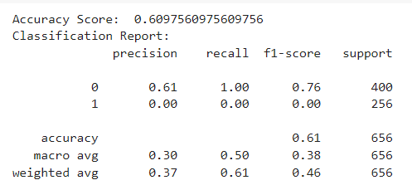

Figure 3. 6: Random Forest's Classification Report

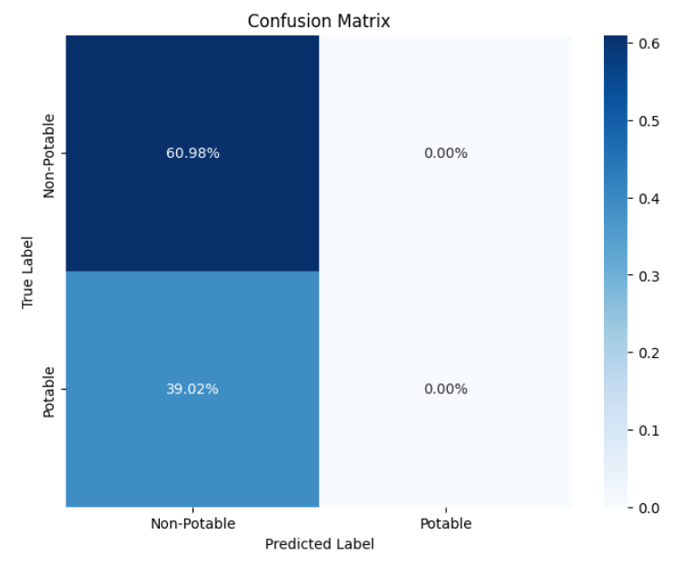

Figure 3. 7: Random Forest's Confusion Matrix

Based on the confusion matrix table, we can see that the prediction results are clearly divided into different parts for observation. There is 60.98% of data that is true positive and 39.02% false negative.

Short summary:

Through the two models: logistic regression and random forest classifier, we can see that they are quite similar and similar in terms of results. However, there seems to be a problem leading to the two models giving values ​​that are not completely correct and have not yet high accuracy. This also often happens in the machine learning process, so it is possible to accept and change to another. This is also the goal of the project when implementing many different models to evaluate and choose the most optimal.

1. **SVM (Support Vector Machine)**

**Support Vector Machine (SVM)** is a supervised machine learning algorithm commonly used for classification and regression tasks. SVM is particularly effective in high-dimensional spaces and is known for its robustness and ability to handle complex datasets.

* **Support Vectors**: Support vectors are the data points that lie closest to the hyperplane. These points are crucial because they determine the position and orientation of the hyperplane.
* **Hyperplane**: In SVM, a hyperplane is a decision boundary that separates different classes in the feature space. The goal of SVM is to find the hyperplane that best separates the classes with the maximum margin.
* **Kernel Trick**: SVM can efficiently perform classification in high-dimensional spaces using the kernel trick, which transforms the data into a higher-dimensional space where a linear separation is possible. Common kernels include the linear kernel, polynomial kernel, and radial basis function (RBF) kernel.
* **Margin**: The margin is the distance between the hyperplane and the closest data points from each class. SVM aims to maximize this margin, as a larger margin is associated with better generalization to unseen data.

Mathematical Formulation:

$$f\left(x\right)=w^{T}x+b$$

where:

* w is the weight vector,
* x is the feature vector,
* b is the bias term.

Kernel Functions

* **Linear Kernel**: $K(x_{i},x_{j})=x_{i}^{T}x_{j}$

​
* **Polynomial Kernel**: $K\left(x_{i},x_{j}\right)={{(x}_{i}^{T}x_{j}+c)}^{d}$

Here is some basic information about SVM as well as the formula, here it is only applied in a basic way to the model to show the results in the same form as the models above. Below are the accuracy results and a table reporting the resulting values.

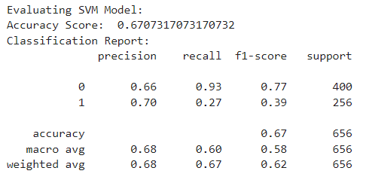

Figure 3. 8: SVM's Classification Report

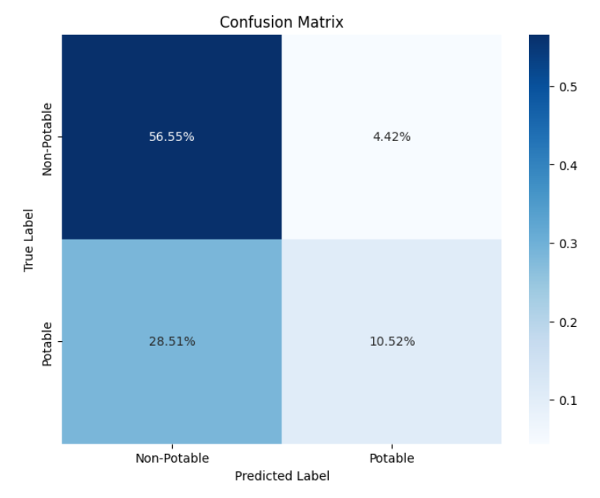

Figure 3. 9: SVM's Confusion Matrix

We can see that the accuracy has increased as well as the values ​​listed more accurately instead of having a value of 0, thereby this model seems to have more reference and comparison value than the two models. Based on that, we can make a preliminary conclusion that SVM does better than the guys above. But let's keep it there, there are a few other models that need to be identified to compare with SVM.

1. **Gradient Boosting**

**Gradient Boosting** is a powerful machine learning technique used for regression and classification tasks. It builds an ensemble of weak learners, typically decision trees, in a sequential manner, where each new tree corrects the errors of the previous trees. This iterative approach improves the model's performance and accuracy.

• **Boosting**: Boosting is an ensemble technique that combines the outputs of several weak learners to create a strong learner. Unlike bagging methods like Random Forest, boosting methods build models sequentially, with each model attempting to correct the errors of the previous one.

• **Gradient Descent**: Gradient boosting uses gradient descent to minimize the loss function. The algorithm fits the new model to the negative gradient of the loss function with respect to the predictions of the ensemble of previous models.

• **Weak Learners**: Typically, the weak learners used in gradient boosting are decision trees with limited depth (also known as stumps). These trees are simple models that can capture only basic patterns in the data.

The goal of gradient boosting is to minimize a loss function L(y,y^), where y is the true label and y^​ is the predicted label.

**Initialization:** Start with an initial model, usually a constant value that minimizes the loss function:

$$f_{0 (x)}=arg\min_{c}\sum_{i=1}^{n}{L(y_{i},c)}$$

**Additive Model**: Construct the model in a stage-wise fashion. For each iteration m, a new weak learner $h_{m}(x)$ is added to the model to reduce the residual errors:

$$F_{0}\left(x\right)=F_{m-1}\left(x\right)+vh_{m}(x)$$

where ν is the learning rate that scales the contribution of each tree.

**Negative Gradient**: At each iteration, fit the new weak learner to the negative gradient of the loss function with respect to the current model predictions:

F=Fm-1

The new weak learner $h_{m}(x)$ is trained on the residuals $r_{im}$ ​.

Then after using the model to train and test, the results received are:

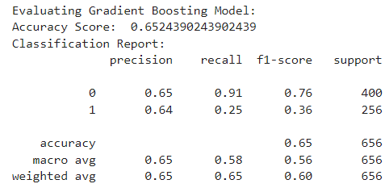

Figure 3. 10: Gradient Boosting's Classification Report

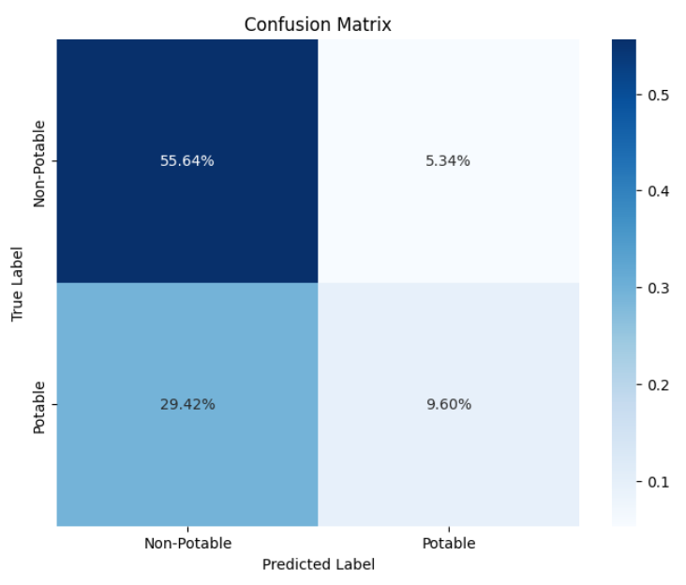

Figure 3. 11: Gradient Boosting's Confusion Matrix

Using gradient boosting also gives very positive results, the values ​​are shown clearly and without missing data, so we can use it to compare with SVM.

1. **Neural Network**

**Neural Networks** are a set of algorithms, modeled loosely after the human brain, that are designed to recognize patterns. They interpret sensory data through a kind of machine perception, labeling, and clustering of raw input. The applications of neural networks include image and speech recognition, natural language processing, and various kinds of decision-making tasks.

Key Concepts of Neural Networks

1. **Neurons and Layers**:
   * **Neuron**: The basic unit of a neural network. Each neuron receives one or more inputs, processes them (usually with a non-linear function), and passes the result to the next layer.
   * **Layer**: Neural networks are organized into layers. The three main types of layers are:
     + **Input Layer**: The layer that receives the initial data.
     + **Hidden Layers**: Layers between the input and output layers where intermediate computations are performed.
     + **Output Layer**: The layer that produces the final output.
2. **Weights and Biases**:
   * **Weights**: Each connection between neurons has an associated weight that adjusts during training.
   * **Bias**: A value added to the weighted sum of inputs before applying the activation function.
3. **Activation Function**: A function applied to the output of each neuron. Common activation functions include:
   * **Sigmoid**: $$σ\left(x\right)=\frac{1}{1+e^{-x}}$$
   * **ReLU** (Rectified Linear Unit):

ReLU(x)=max(0,x)

* + **Tanh**: $$tanh\left(x\right)=\frac{e^{x}-e^{-x}}{e^{x}+e^{-x}}$$

1. **Forward Propagation**: The process of passing the inputs through the network to obtain the output.
2. **Backpropagation**: The process of updating the weights and biases in the network by calculating the gradient of the loss function with respect to each weight and bias, using the chain rule of calculus. This is typically done using an optimization algorithm like gradient descent.

Mathematical Formulation

For a single neuron:

$$y=f\sum_{i=1}^{n}{w_{i}w_{j}+b}$$

Where:

* y is the output,
* f is the activation function,
* wi are the weights,
* xi​ are the inputs,
* b is the bias.

Apply the model to the data, the report table and confusion matrix will be represented as follows:

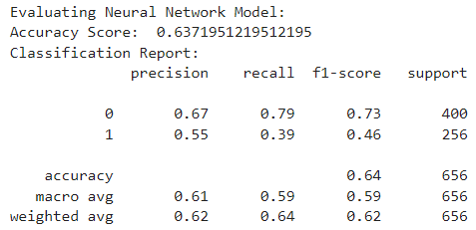

Figure 3. 12: Neural Network's Classification Report

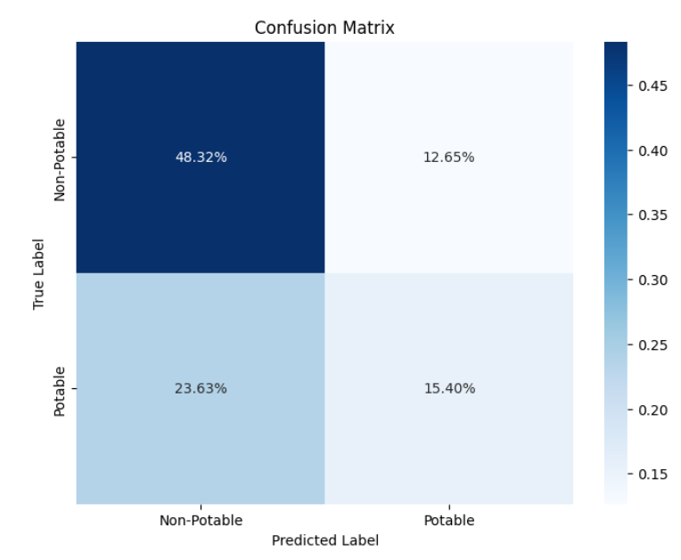

Figure 3. 13: Neural Network's Confusion Matrix

After applying a neural network to the dataset, the model was trained to recognize patterns in the data through multiple layers of interconnected neurons. The training process involved adjusting the network's weights to minimize the error between the predicted and actual outcomes.

# CHAPTER IV: COMPARISION

Now, we jump to the last part of our project, where we compare all models, we deployed and choose the model that is the best fit for the goal of the project.

In this part, I write a Python function to print out performance metrics and the time to train and predict for each models:

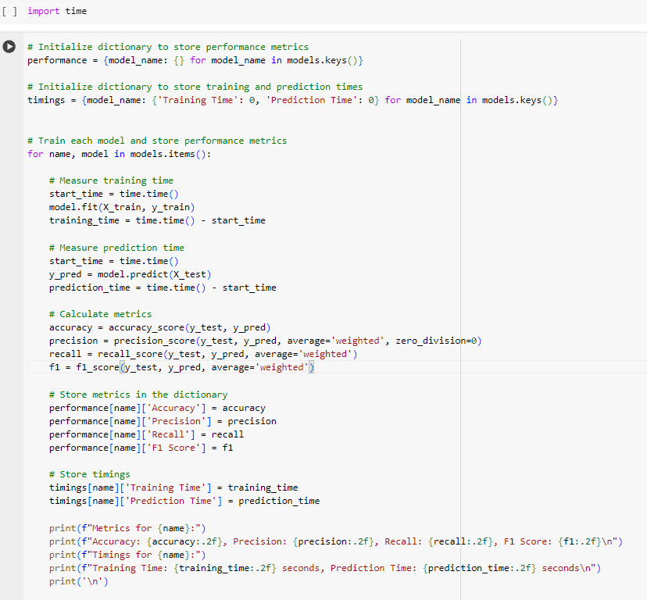

Figure 4. 1: Compare Function

And here is the result:

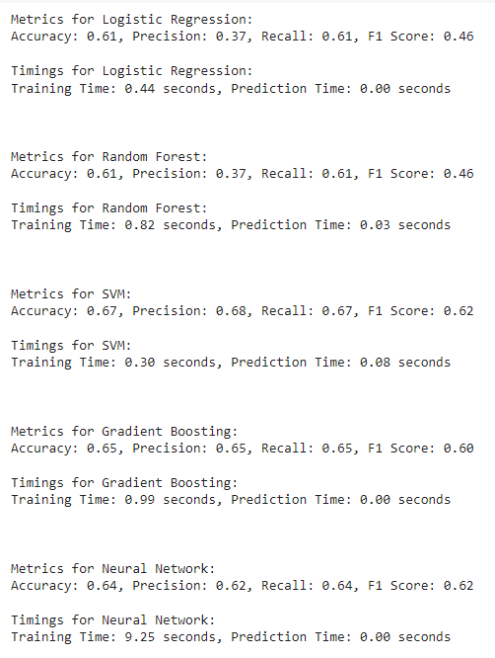

Figure 4. 2: Comparison Results

Next, we display charts of performance metrics to facilitate comparison among the five models.

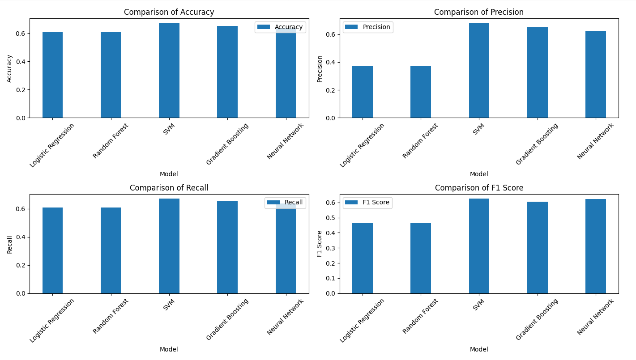

Figure 4. 3: Chart of Performance Metrics

Timing table:

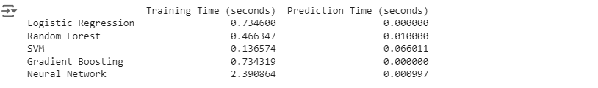

Figure 4. 4: Timing Table

Model Performance Overview:

* Logistic Regression & Random Forest

Performance Metrics: Both models show the same performance metrics with an accuracy of 0.61, precision of 0.37, recall of 0.61, and F1 score of 0.46. These are the lowest among all models.

Timings: Logistic Regression is quite fast, with the shortest training time (0.44 seconds) and no prediction delay (0.00 seconds). Random Forest, while slightly slower, is still reasonably fast but less efficient in terms of precision.

* SVM (Support Vector Machine)

Performance Metrics: It leads in terms of accuracy (0.67), precision (0.68), recall (0.67), and F1 score (0.62).

Timings: Has a moderate training time (0.30 seconds) but the longest prediction time (0.08 seconds), which could be a factor if prediction speed is critical.

* Gradient Boosting

Performance Metrics: Scores well with an accuracy of 0.65, precision of 0.65, recall of 0.65, and an F1 score of 0.60.

Timings: Has the longest training time among the faster models (0.99 seconds), but excels with a prediction time of 0.00 seconds, indicating very fast inference.

* Neural Network

Performance Metrics: Shows strong results with an accuracy of 0.64, precision of 0.62, recall of 0.64, and F1 score of 0.62.

Timings: Significantly longer training time (9.25 seconds), which is the longest by a substantial margin, though it matches the fastest models in prediction time (0.00 seconds).

**Conclusion:**

Best Overall Performance: SVM stands out as the best model given its highest scores across all key performance metrics. While its prediction time is the longest among the models, it remains within a reasonable range (0.08 seconds), which is acceptable in many applications, especially given its superior accuracy and precision.

Speed & Efficiency: Gradient Boosting could be a close contender, especially for applications where fast prediction times are crucial, despite slightly lower performance metrics compared to SVM. Its zero-prediction time is notable, although it takes slightly longer to train.

Neural Network might be considered if the training phase can accommodate longer durations, given its competitive performance and instantaneous predictions. However, its lengthy training time might be a bottleneck in scenarios requiring frequent retraining or on-the-fly model updates.

**Final Recommendation:** The SVM is recommended for scenarios where the highest model accuracy and precision are crucial, and slight delays in prediction times are acceptable. If prediction speed is paramount, Gradient Boosting offers an excellent balance between speed and accuracy.

# CHAPTER V: CONCLUSION AND FUTURE WORK

1. **Conclusion**

Applying different models shows that data can have different values ​​through different models, thereby making the correct choice for the purpose and target audience.

This project aimed to evaluate the potability of water based on its chemical characteristics using several machine learning models. The models employed included Logistic Regression, Random Forest, SVM, Gradient Boosting, and Neural Networks, each evaluated on metrics such as accuracy, precision, recall, and F1 score. Through rigorous testing, the SVM model demonstrated superior performance, achieving the highest accuracy and precision among the models tested. This suggests that SVM is particularly well-suited for classifying complex, high-dimensional data such as water quality metrics. The project confirmed that machine learning techniques could effectively predict water quality from chemical properties, indicating their potential utility in real-world applications like water treatment and safety regulation. The application of these models provides a foundation for more informed decision-making in public health and environmental protection.

1. **Future work**

In the future, we may use algorithms such as more advanced SVM to visualize in 3D space.



Figure 5. 1: SVM in 3D

We can also apply other methods to produce more predictive results, such as KNN (K-Nearest Neighbors) or Decision Tree to apply to projects to gain more knowledge and experience when practicing with those models.

We can also do better pre-processing to produce clear data, as well as try different types of live data or real-time data to learn more about data processing and apply models.

One more aspect to consider is the addition of the Hyperparameter Tuning section. However, due to the excessive time required to run this task, we have not included it yet. We plan to address and possibly rectify this issue later.

# REFERENCES

[1] [**Jinal Patel**](https://pubmed.ncbi.nlm.nih.gov/?term=Patel%20J%5BAuthor%5D),[**Charmi Amipara**](https://pubmed.ncbi.nlm.nih.gov/?term=Amipara%20C%5BAuthor%5D),[**Tariq Ahamed Ahanger**](https://pubmed.ncbi.nlm.nih.gov/?term=Ahanger%20TA%5BAuthor%5D),[**Komal Ladhva**](https://pubmed.ncbi.nlm.nih.gov/?term=Ladhva%20K%5BAuthor%5D),[**Rajeev Kumar Gupta**](https://pubmed.ncbi.nlm.nih.gov/?term=Gupta%20RK%5BAuthor%5D),[**Hashem O. Alsaab**](https://pubmed.ncbi.nlm.nih.gov/?term=Alsaab%20HO%5BAuthor%5D),,[**Yusuf S. Althobaiti**](https://pubmed.ncbi.nlm.nih.gov/?term=Althobaiti%20YS%5BAuthor%5D),,and [**Rajnish Ratna**](https://pubmed.ncbi.nlm.nih.gov/?term=Ratna%20R%5BAuthor%5D): *A Machine Learning-Based Water Potability Prediction Model by Using Synthetic Minority Oversampling Technique and Explainable AI.* <https://www.ncbi.nlm.nih.gov/pmc/articles/PMC9514946/>

[2] M. K. Nallakaruppan, E. Gangadevi, M. Lawanya Shri, Balamurugan Balusamy, Sweta Bhattacharya & Shitharth Selvarajan: *Reliable water quality prediction and parametric analysis using explainable AI models* <https://www.nature.com/articles/s41598-024-56775-y>